UNITED WAY OF OXFORD-LAFAYETTE COUNTY

FISCAL YEAR 2026-2027 PRIMARY FISCAL AGENT PRE-APPLICATION

This pre-application must be received via email at kurt@unitedwayoxfordms.org by 5:00 p.m. on March 10, 2026. The pre-application should be emailed as a Word document (*.docx or *.doc) and any accompanying documentation (board roster, etc.) should be sent as a separate combined PDF file.

This Primary Fiscal Agent Pre-Application must be completed by agencies planning to submit a Program Grant Application as the primary fiscal agent. Agencies will not be eligible to apply for United Way of Oxford-Lafayette County (UWOLC) Program Grant Funding if they have not submitted this pre-application by the stated deadline. For more details, please see the accompanying Policies & Procedures Manual.

Please note:

1. To be eligible, agencies must have a 501(c)(3) tax-exempt status. Public entities such as school districts, libraries, and universities may also be eligible. For information regarding this exemption, please email UWOLC at kurt@unitedwayoxfordms.org.
2. Agencies applying as partners, but not as primary fiscal agents, do not need to complete this application.
3. An agency applying for funding for multiple programs must only submit this Primary Fiscal Agent Pre-Application once.

A. AGENCY CONTACT INFORMATION

Agency Name (Primary Fiscal Agent) | Agency Address
Primary Contact Name | Primary Contact Role/Title
Primary Contact Phone | Primary Contact Email Address

B. AGENCY CHARACTERISTICS

Mission Statement
Tax Status Designation (e.g., 501(c)(3)) | Management Structure (e.g., Board of Directors)
Employer Identification Number | Board/Advisory Committee Meeting Frequency
Number of Paid Staff (Indicate if Full-Time or Part-Time) | Approximate Number of Volunteers Per Year
Fiscal Year (e.g., July 1st to June 30th) | Year of Establishment
If applicable, describe your agency’s prior relationship with United Way (funding history, collaborative projects, etc.).
(100-Word Maximum)

C. AGENCY FISCAL MANAGEMENT ASSURANCES & DOCUMENTS
This agency: | Yes / No / Not Applicable
- Is currently in compliance with all federal and state payroll filings
- Is currently in compliance with all relevant funding, regulatory, accrediting, and licensing bodies
- Is current on all debt payments
- Has not been named in an active lawsuit or a lawsuit filed within the last 36 months (Yes is the appropriate response if you have not been named)
- Has written financial management policies and procedures in place

Please attach an accompanying explanation for any “No” or “Not Applicable” answer noted above.

As a supplement to this pre-application, submit the following documents as a combined PDF file or as multiple PDF files. Each document must be clearly labeled at the top of its first page and in the specified order. If a document is either not applicable or not available, an explanation must be included in its place. If you have any questions or issues, contact UWOLC prior to the submission deadline.

- Board Roster (include officer roles, employer/organization information, etc.)
- Balance Sheet* for your most recently completed fiscal year with a previous year comparison (include audited financial statements if they are available)
- Income Statement* for your most recently completed fiscal year with a previous year comparison (include audited financial statements if they are available)
- Annual Budget* for current and previous fiscal year
- Form 990/990-EZ/990-N (most recent submission)

- For large entities, the UWOLC Finance Committee requests that at minimum an annual budget for the applicable program(s) be submitted along with the entity’s balance sheet, income statement, and annual budget. The committee requests an income statement and/or balance sheet for the applicable program(s) if the documents can be readily produced, or for the respective division/department in lieu of documentation for the applicable program(s).

D. AGENCY CERTIFICATIONS

- Are you currently registered as a charity in the State of Mississippi?
- Expiration Date of Charity Registration (e.g., May 15, 2026)
- On what date was your last audit, financial review, or compilation completed?
- Indicate the fiscal year and if it was an audit, financial review, or compilation
- On what date was your last Form 990/990-EZ/990-N submitted?

- Indicate the fiscal year and if it was Form 990, 990-EZ, or 990-N

E. AGENCY INFORMATION – CURRENT FINANCIAL POSITION

- Disclose any material changes that have occurred since the end of your most recently completed fiscal year. Examples would include grant awards received or lost as well as other pertinent information related to your current financial position. Please feel free to include the most recent profit-and-loss statement and/or balance sheet presented to your board of directors to supplement the required financial documents on the previous page.

F. AGENCY ASSURANCES – COMPLIANCE WITH UNITED WAY POLICIES

If an agency’s program application is ultimately funded by UWOLC, the primary fiscal agent assures it will:

- Submit a mid-year report to UWOLC that includes a financial update as well as beneficiary and outcome measurement results based on local data.

- Provide a complete and final accounting of all UWOLC funds received and spent at the end of the funding period.

- Apply all UWOLC funds received and spent to Lafayette County, Mississippi.

- Agree to promptly return any unexpended or improperly expended UWOLC funds at the end of the funding period or as requested by UWOLC.

- Submit a year-end report to UWOLC that includes beneficiary and outcome measurement results based on local data as well as a description of how those results are being used.

- Notify UWOLC immediately of any material change in the program plan described in the application.

- Promote an inclusive environment that denounces racial and ethnic discrimination in all forms.

- Include the phrase “funded in part by United Way of Oxford-Lafayette County” and/or the UWOLC logo in all publications, press releases, flyers, signs, presentations, etc. associated with a funded program as well as in other appropriate cases.

Assist with UWOLC’s annual campaign, including providing support, volunteers, etc. for its public relations and marketing efforts as well as participating in its campaign kick-off luncheon and other special events.

Not directly solicit local employee groups for payroll deductions at any time or encourage designated contributions to UWOLC.

- Operate in compliance with all applicable statutes, licensing, and government code requirements.

G. AGENCY SIGNATURE

A handwritten, typed, or electronic signature provided by an authorized representative (e.g., officer) of the agency attests that the information submitted in conjunction with this pre-application is accurate and certifies the agency’s agreement to all the aforementioned assurances. The submission of a typed or electronic signature below verifies the agency’s agreement that a typed or electronic signature is the same as a handwritten signature for the purposes of validity, enforceability, and admissibility.

Authorized Representative Name & Title

Authorized Representative Signature

Date

For each program on which the primary fiscal agent agency anticipates making sub-grants to another agency or agencies, please include the following information (if known at the time this pre-application is submitted).

Program Name:

Anticipated Partner Agency/Organization:

Contact Person:

Phone:

Email:

Program Name:

Anticipated Partner Agency/Organization:

Contact Person:

Phone:

Email:

Program Name:

Anticipated Partner Agency/Organization:

Contact Person:

Phone:

Email:

Program Name:

Anticipated Partner Agency/Organization:

Contact Person:

Phone:

Email:

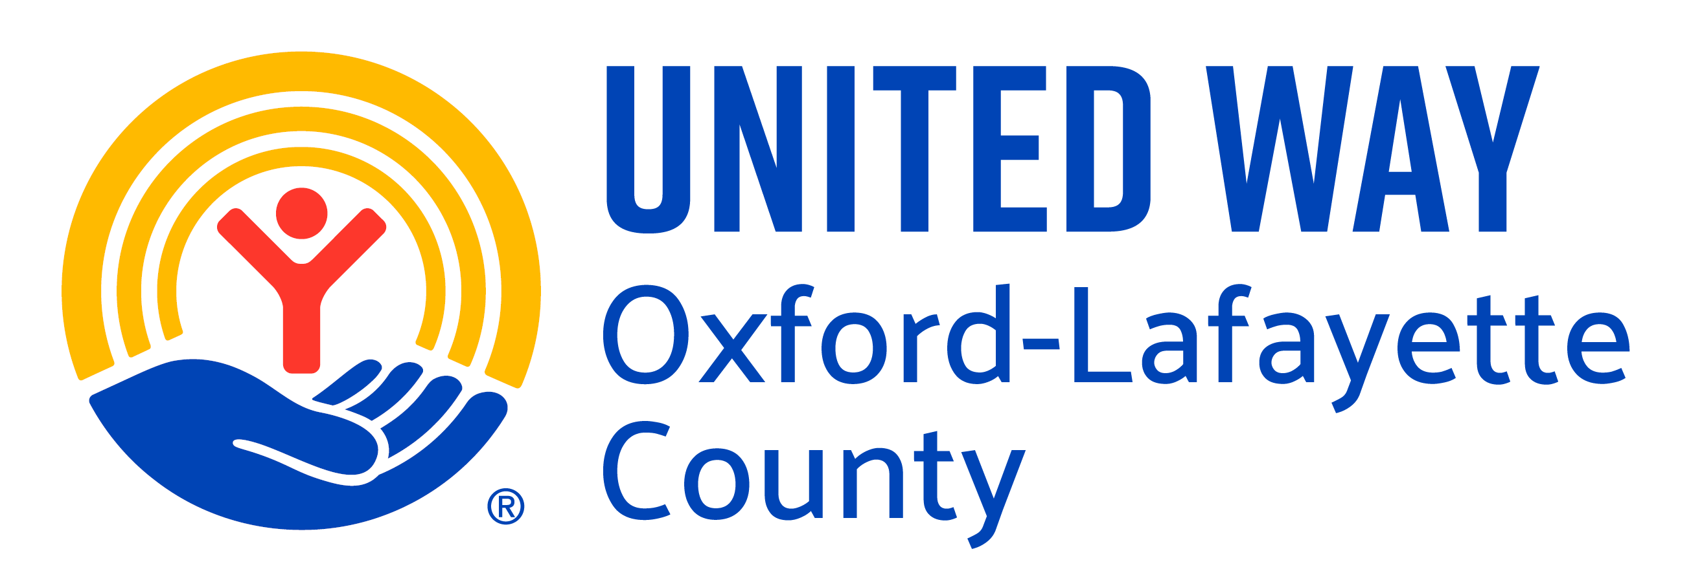

Anti-Terrorism Compliance Measures Certification

In compliance with the USA PATRIOT Act and other counterterrorism laws, United Way of Oxford-Lafayette County (UWOLC) will run each agency receiving funds against the Anti-Terrorism Watch list. UWOLC also requires that each agency receiving funds certify the following:

“I hereby certify on behalf of

Agency Name (Primary Fiscal Agent)

that all UWOLC funds and donations will be used in compliance with all applicable anti-terrorist financing and asset control laws, statutes, and executive orders.”

A handwritten, typed, or electronic signature provided by an authorized representative (e.g., officer) of the partner agency attests that the information submitted in conjunction with this form is accurate and certifies the partner agency’s agreement to the aforementioned statement. The submission of a typed or electronic signature below verifies the partner agency’s agreement that a typed or electronic signature is the same as a handwritten signature for the purposes of validity, enforceability, and admissibility.

Authorized Representative Name & Title

Authorized Representative Signature

Date

