# United Way of Oxford-Lafayette County

# Fiscal Year 2023-2024 Primary Fiscal Agent Pre-Application

This pre-application must be received via email at [kurt@unitedwayoxfordms.org](mailto:kurt@unitedwayoxfordms.org) by 5:00 p.m. on March 1, 2023. The pre-application should be emailed as a Word document (*.docx or *.doc) and any accompanying documentation (board roster, etc.) should be sent as a separate combined PDF file.

This Primary Fiscal Agent Pre-Application must be completed by agencies planning to submit a Program Grant Application as the primary fiscal agent. Agencies will not be eligible to apply for United Way of Oxford-Lafayette County (UWOLC) Program Grant Funding if they have not submitted this pre-application by the stated deadline. For more details, please see the accompanying Policies & Procedures Manual.

Please note:

1. To be eligible, agencies must have a 501(c)(3) tax-exempt status. Public entities such as school districts, libraries, and universities may also be eligible. For information regarding this exemption, please contact the UWOLC at [kurt@unitedwayoxfordms.org](mailto:kurt@unitedwayoxfordms.org).

2. Agencies applying as partners, but not as primary fiscal agents, do not need to complete this application.

3. An agency applying for funding for multiple programs must only submit this Primary Fiscal Agent Pre-Application once.

## A. Agency Contact Information

## 

|  |  |
| --- | --- |
| **Agency Name (Primary Fiscal Agent)** | **Agency Address** |
|  |  |
| **Primary Contact Name** | **Primary Contact Role** |
|  |  |
| **Primary Contact Phone** | **Primary Contact Email Address** |
|  |  |

## B. Agency Characteristics

## 

|  |  |
| --- | --- |
| **Agency Mission Statement** | |
|  | |
| **Agency Tax Status Designation (e.g., 501(c)(3))** | **Agency Management Structure (e.g., Board, LLC)** |
|  |  |
| **Agency Employer Identification Number** | **Board/Advisory Committee Meeting Frequency** |
|  |  |
| **Total Number of Paid Staff (Indicate if Full-Time or Part-Time)** | **Approximate Number of Volunteers Per Year** |
|  |  |
| **If Applicable, Describe the Agency’s Prior Relationship with United Way (e.g., Funding History, Collaborative Projects).**  **(100-Word Maximum)** | |
|  | |

**C. Agency Fiscal Management Assurances & Documents**

|  |  |
| --- | --- |
| This agency: | Yes / No / Not Applicable |
| 1. Is currently in compliance with all federal and state payroll filings |  |
|  | |
| 1. Is currently in compliance with all relevant funding, regulatory, accrediting, and licensing bodies |  |
|  | |
| 1. Is current on all debt payments |  |
|  | |
| 1. Has not been named in an active lawsuit or a lawsuit filed within the last 36 months (Yes is the appropriate response if you have not been named) |  |
|  | |
| 1. Has written financial management policies and procedures in place |  |

***Please attach an accompanying explanation for any “No” or “Not Applicable” answer noted above.***

As a supplement to this pre-application, submit a separate combined PDF file containing an electronic copy of each of the following documents. Each document must be clearly labeled at the top of its first page and in the specified order. If a document is either not applicable or not available, an explanation must be included in its place. If you have any questions or issues emailing the documents as a single combined PDF file, contact the UWOLC prior to the submission deadline.

1. **Board Roster** (include officer roles, employer/organization information, etc.)
2. **Balance Sheet\*** for your most recently completed fiscal year with a previous year comparison (include audited financials if available)
3. **Profit & Loss Statement\*** for your most recently completed fiscal year with a previous year comparison (include audited financials if available)
4. **Annual Budget\*** for current and previous fiscal year
5. **Form** **990/990-EZ/990-N** (most recent submission)
6. Disclose any material changes that have occurred since the end of your most recently completed fiscal year.

* For large entities, the UWOLC Finance Committee requests that at minimum an annual budget for the applicable program(s) be submitted along with the entity’s balance sheet, profit and loss statement, and annual budget. A balance sheet and profit and loss statement for the applicable program(s) is requested if the documentation can be readily produced. In lieu of documentation for the applicable program, division/department information is requested.

**D. Agency Certifications**

|  |  |
| --- | --- |
| 1. Are you currently registered as a charity in the State of Mississippi? |  |
|  |  |
| * Expiration Date of Charity Registration (e.g., May 15, 2023) |  |
|  |  |
| 1. On what date was your last audit/financial review/compilation completed? |  |
|  |  |
| * Indicate whether it was an audit, financial review, or compilation |  |
|  |  |
| 1. On what date was your last Form 990/990-EZ/990-N submitted? |  |

|  |  |
| --- | --- |
| * Indicate whether it was Form 990, 990-EZ, or 990-N |  |

**E. Agency Assurances – Compliance with United Way Policies**

If an agency’s program application is ultimately funded by the UWOLC, the primary fiscal agent assures it will:

* Submit a mid-year report to the UWOLC that includes a financial update as well as beneficiary and outcome measurement results based on local data.
* Provide a complete and final accounting of all UWOLC funds received and spent at the end of the funding period.
* Apply all UWOLC funds received and spent to Lafayette County, Mississippi.
* Agree to promptly return any unexpended or improperly expended UWOLC funds at the end of the funding period or as requested by the UWOLC.
* Submit a year-end report to the UWOLC that includes beneficiary and outcome measurement results based on local data as well as a description of how those results are being used.
* Notify the UWOLC immediately of any material change in the program plan described in the application.
* Promote an inclusive environment that denounces racial and ethnic discrimination in all forms.
* Include the phrase “funded in part by the United Way of Oxford-Lafayette County” and/or the UWOLC logo in all publications, press releases, flyers, signs, presentations, etc. associated with a funded program as well as in other appropriate cases.
* Assist with the UWOLC’s annual campaign, including providing support, volunteers, etc. for its public relations and marketing efforts as well as participating in its campaign kick-off luncheon and other special events.
* Not directly solicit local employee groups for payroll deductions at any time or encourage designated contributions to the UWOLC.
* Operate in compliance with all applicable statutes, licensing, and government code requirements.

**F. Agency Signature**

A handwritten, typed, or electronic signature provided by an authorized representative (e.g., officer) of the agency attests that the information submitted in conjunction with this pre-application is accurate and certifies the agency’s agreement to all of the aforementioned assurances. The submission of a typed or electronic signature below verifies the agency’s agreement that a typed or electronic signature is the same as a handwritten signature for the purposes of validity, enforceability, and admissibility.

|  |
| --- |
|  |

Authorized Representative Name & Title

|  |
| --- |
|  |

Authorized Representative Signature

|  |
| --- |
|  |

Date

For each program on which the primary fiscal agent agency anticipates making sub-grants to another agency or agencies, please include the following information (if known at the time this pre-application is submitted).

|  |  |
| --- | --- |
| Program Name: |  |
|  |  |
| Anticipated Partner Agency/Organization: |  |
|  |  |
| Contact Person: |  |
|  |  |
| Phone: |  |
|  |  |
| Email: |  |

|  |  |
| --- | --- |
| Program Name: |  |
|  |  |
| Anticipated Partner Agency/Organization: |  |
|  |  |
| Contact Person: |  |
|  |  |
| Phone: |  |
|  |  |
| Email: |  |

|  |  |
| --- | --- |
| Program Name: |  |
|  |  |
| Anticipated Partner Agency/Organization: |  |
|  |  |
| Contact Person: |  |
|  |  |
| Phone: |  |
|  |  |
| Email: |  |

|  |  |
| --- | --- |
| Program Name: |  |
|  |  |
| Anticipated Partner Agency/Organization: |  |
|  |  |
| Contact Person: |  |
|  |  |
| Phone: |  |
|  |  |
| Email: |  |

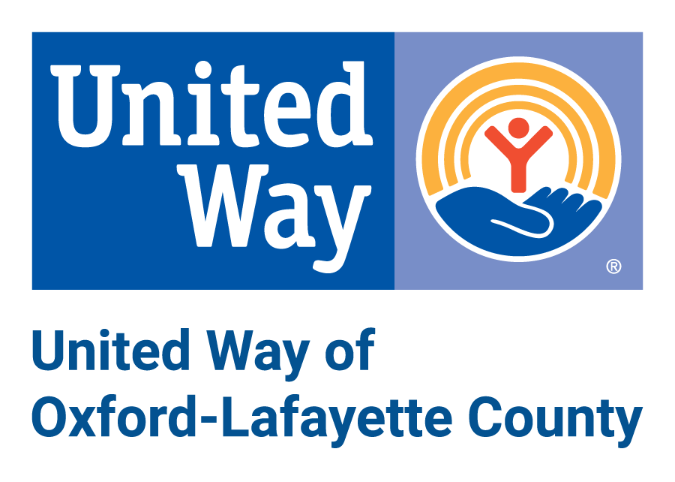

Anti-Terrorism Compliance Measures Certification

In compliance with the USA PATRIOT Act and other counterterrorism laws, the United Way of Oxford-Lafayette County (UWOLC) will run each agency receiving funds against the Anti-Terrorism Watch list. The UWOLC also requires that each agency receiving funds certify the following:

“I hereby certify on behalf of

|  |
| --- |
|  |

Agency Name (Primary Fiscal Agent)

that all UWOLC funds and donations will be used in compliance with all applicable anti-terrorist financing and asset control laws, statutes, and executive orders.”

A handwritten, typed, or electronic signature provided by an authorized representative (e.g., officer) of the partner agency attests that the information submitted in conjunction with this form is accurate and certifies the partner agency’s agreement to the aforementioned statement. The submission of a typed or electronic signature below verifies the partner agency’s agreement that a typed or electronic signature is the same as a handwritten signature for the purposes of validity, enforceability, and admissibility.

|  |
| --- |
|  |

Authorized Representative Name & Title

|  |
| --- |
|  |

Authorized Representative Signature

|  |
| --- |
|  |

Date